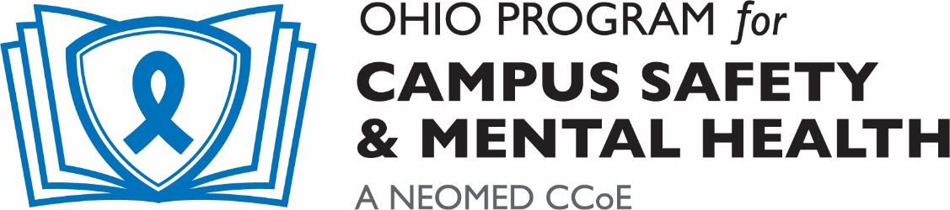
Creating Community Wellness:
Equity and Inclusion in Student Mental Health
Conducting a Campus Mental Health Needs Assessment: Innovative Strategies to Engage Students of Color
______________________________________________
Session Description:
The Equity in Mental Health Framework (EMHF), published by The Steve Fund and JED Foundation, focuses on addressing the unique mental health needs of students of color. Case Western Reserve University (CWRU) is implementing the framework and using its recommendations to promote the health and well-being of students of color with intentional, evidence-based programming and services delivered through a campus-wide system of support. One recommendation from the EMHF is that campuses gather information from students of color to understand their needs and challenges regarding mental health and well-being, sense of belonging, and academic success. In this session, I describe our unique approach to needs assessment. This approach included a qualitative analysis of the content posted on a CWRU-specific social media page with anonymous stories about being Black at the university. Attendees will learn how the analysis was conducted, how key themes were identified, and how those themes were incorporated directly into interventions. This session will also review how CWRU is conducting focus groups with students of color in a time when we cannot gather in person. I will discuss strategies for virtually recruiting students, in addition to ways to conduct the groups to preserve the in-depth understanding that comes from listening directly to students. Consistent with the EMHF’s recommendations, this session will support information sharing through disseminating our approach to needs assessment with other colleges and universities. Finally, this session will end with a brief brainstorming period and work with attendees to develop strategies that will work best on their campuses to engage student voices.

Learning Objectives:
- Participants will gain introductory understanding of the Equity in Mental Health Framework.
- Participants will learn a unique strategy for conducting a needs assessment utilizing social media.
- Participants will learn considerations for conducting virtual focus groups with students of color.

Link to join:
https://neomed.zoom.us/j/92711767516?pwd=d0JhcEh0UGtud0dJMzlVWDEvb20vZz09
Password: 231105



