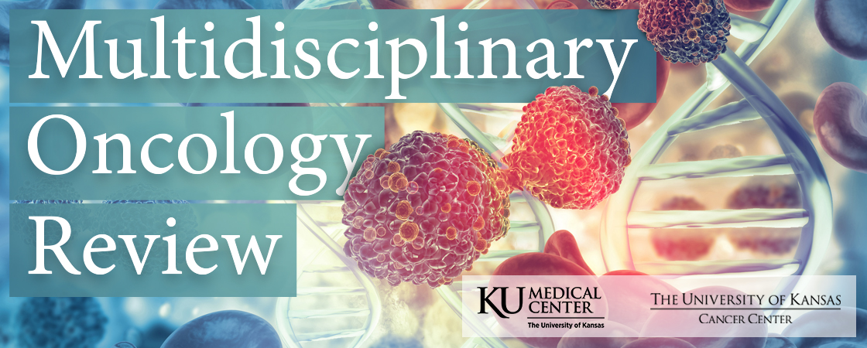

University of Kansas Medical Center
Health Education Building
2060 West 39th Ave.
Kansas City, Kansas 66103

Saturday, April 29, 2023
Registration/Sign-In 7:30 AM – 7:55 AM
Conference 7:55 AM – 3:00 PM

CONTINUING EDUCATION CREDIT OR A CERTIFICATE OF ATTENDANCE
Activity Code:
The code will expire Saturday, May 6, at 5:00 p.m.

Sign-in Methods:
- Text the activity code to (828) 295-1144
- Visit www.eeds.com
Enter the activity code, then enter the email address associated with your account.

Overview:

The University of Kansas Multidisciplinary Oncology Review is designed by experts in the field of oncology and aimed towards the educational needs of community physicians and other healthcare providers involved in the multidisciplinary management of patients with Genitourinary, Pancreatic, and Colon Cancers. Controversies and changes in treatment paradigms will be presented through short, practical, up-to-date lectures, followed by a panel discussion and Q&A session for each tumor type.

Target Audience

This symposium is designed for medical oncologists, surgeons, radiation oncologists, gastroenterologists, radiologists, pathologists, primary care physicians, basic scientists, registered nurses, advanced practice providers, pharmacists, and other health care professionals.

Objectives:

At the conclusion of the event, participants should be able to:

- Analyze recent advances in the treatment of three types of cancer: renal cell carcinoma, colon cancer, and pancreatic adenocarcinoma.
- Evaluate novel treatment approaches and discuss strategies to integrate them into current clinical practice.
- Assess the clinical utility of circulating tumor DNA in the management of patients with colorectal cancer.
- Examine the role of radiation therapy in the management of patients with renal cell carcinoma, pancreatic cancer, and colorectal cancer.
- Examine the role of organ transplant in the treatment of metastatic cancers.
- Evaluate the indications and utility of cytoreductive surgery and heated intraperitoneal chemotherapy in the treatment of metastatic cancer.

Agenda

7:30 a.m. Registration and Exhibits

7:55 a.m. Welcome and Course Overview

Session 1: Genitourinary Cancer

8:00 – 8:20 a.m. The Surgical Management of Renal Cell Carcinoma

Eugene K. Lee, MD, Associate Professor, Director, Division of Urologic Oncology, Department of Urology, University of Kansas Medical Center

8:20 – 8:40 a.m. The Role of Radiation Therapy in Renal Cell Carcinoma
Jay Shiao, MD, MPH, Assistant Professor, Department of Radiation Oncology, University of Kansas Medical Center
8:40 – 9:00 a.m. Updates in Renal Cell Carcinoma
Saqib Abbasi, MD, Assistant Professor, Early Phase Program, University of Kansas Medical Center

9:00 – 9:15 a.m. Panel Discussion - Moderators: Mazin Al-Kasspooles, MD, FACS and Raed Al-Rajabi, MD
Session 2: Pancreatic Cancer
9:15 – 9:35 a.m. Advances in Pancreatic Cancer
Anup Kasi, MD, MPH, Associate Professor, Vice-Chair of GI Working Group, Division of Medical Oncology, University of Kansas Medical Center
9:35 – 9:55 a.m. Updates on Radiation Therapy in Pancreatic Cancer
David Akhavan, MD, PhD, Assistant Professor and Translational Physician Scientist, Department of Radiation Oncology, University of Kansas Medical Center
9:55 – 10:15 a.m. Updates on Transplant in the Treatment of Cancer
Clay King, MD, Assistant Professor, Division of Transplant and HPB Surgery, Department of Surgery, University of Kansas Medical Center
10:15 – 10:30 a.m. Panel Discussion - Moderators: Mazin Al-Kasspooles, MD, FACS and Raed Al-Rajabi, MD
10:30 – 11:00 a.m. Break and Exhibitor Opportunity
Session 3: Colon Cancer
11:00 – 12:00 p.m. Keynote Presentation - Abdominal Regional Therapy: Indications and Considerations
Tyler Mouw, MD, Assistant Professor, Surgical Oncology and HPB Surgery, Department of Surgery, Texas Tech University Health Sciences Center.
12:00 – 12:40 p.m. Lunch catered by Q39
12:40 – 1:00 p.m. Developments in Colorectal Cancer
Joaquina Baranda, George and Floriene Lieberman Professor, Medical Director,
Early Phase Research, Clinical Research Center, The University of Kansas Cancer Center
1:00– 1:20 p.m. Updates in Radiation Therapy for Rectal Cancer
Christen Elledge, MD, Assistant Professor, Department of Radiation Oncology, University of Kansas Medical Center
1:20 – 1:40 p.m. Updates in Colon and Rectal Cancer Surgery
John Ashcraft, DO, FACS, FASCRS, Associate Professor, Surgery; Division Chief, Colorectal and Oncologic Surgery Division; Vice-Chair of Quality and Safety for the Department of Surgery

1:40 – 1:55 p.m. Panel Discussion - Moderators: Mazin Al-Kasspooles, MD, FACS and Raed Al-Rajabi, MD
1:55 – 2:55 p.m. Keynote Presentation - Circulating Tumor DNA Applications in Colorectal Cancer
Arvind Dasari, MD, MS, Associate Professor, Department of Gastrointestinal Medical Oncology, The University of Texas MD Anderson Cancer Center
2:55 – 3:00 p.m. Closing remarks

Course Co-Directors

Mazin Al-Kasspooles, MD, FACS, Professor of Surgery, Director, Regional Cancer Therapies Program, Department of Surgery, Division of Surgical Oncology, University of Kansas Medical Center

Raed Al-Rajabi, M.D., Associate Professor of Medicine, Department of Internal Medicine, Division of Medical Oncology, University of Kansas Medical Center

Planning Committee

Mazin Al-Kasspooles, MD, FACS, Professor of Surgery, Director, Regional Cancer Therapies Program, Department of Surgery, Division of Surgical Oncology, University of Kansas Medical Center

Raed Al-Rajabi, MD, Associate Professor of Medicine, Department of Internal Medicine, Division is Medical Oncology, University of Kansas Medical Center

Denise Ishmael, Administrative Assistant to Physicians, Division of Medical Oncology, Department of Internal Medicine, The University of Kansas Health System, The University of Kansas Cancer Center

Kyle Robbins, RN, MSN, OCN, Oncology Education Specialist, University of Kansas Cancer Center
Molly Smith, MS, Continuing Education Coordinator, Office of Continuing Education and Professional Development, University of Kansas Medical Center
Brittany Waller, MSN, RN, OCN, Oncology Education Specialist, University of Kansas Cancer Center

Accreditation

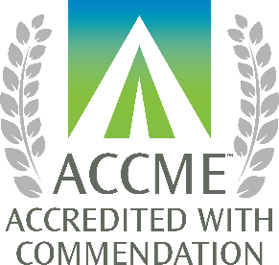
Physicians: The University of Kansas Medical Center Office of Continuing Medical
Education is accredited by the Accreditation Council for Continuing Medical Education
(ACCME) to provide continuing medical education for physicians.

The KU Medical Center Office of Continuing Medical Education designates this live
activity for a maximum of 5.75 AMA PRA Category 1 Credits TM. Physicians should claim
only the credit commensurate with the extent of their participation in the activity.

APRN/RN: The University of Kansas Medical Center Area Health Education Center East is approved as a provider of CNE by the Kansas State Board of Nursing. This course offering is approved for 7.1 contact hours applicable for APRN or RN relicensure. Kansas State Board of Nursing provider number: LT0056-0749. Mary Beth Warren, MS, RN, Coordinator.

Nursing attendance requirement: Credit will be awarded based upon documented attendance. The conference is in 3 topic areas. All presentations within a topic area must be attended in their entirety to claim credit for the section.

Faculty and Planning Committee Disclosure Information

The following presenters and planning committee members report no relationships of a financial, professional, or personal nature with ineligible companies over the past 24 months: Mazin Al-Kasspooles, MD; Denise Ishmael, AA; Kyle Robbins, RN, MSN, OCN; Molly Smith, MS; Brittany Waller, RN, MSN, OCN; Saqib Abbasi, MD; Eugene Lee, MD; Jay Shiao, MD; Clay King, MD; John Ashcraft, DO; Christen Elledge, MD; Tyler Mouw, MD

The following presenters and planning committee members have disclosed a financial relationship with one or more ineligible companies whose primary business is producing, marketing, selling, re-selling, or distributing healthcare products used by or on patients over the past 24 months: Raed Al-Rajabi, MD; David Akhavan, MD; Anup Kasi Loknath Kumar, MD; Joaquina Baranda, MD; Arvind Dasari, MD

Raed Al-Rajabi, MD, recieves grant funding from AstraZeneca, Incyte, Eureka Therapeutics, and Turnstone Biologics; honoraria from Astra Zeneca, Amgen, and Taiho; stock options from Seagen and Actinium Pharmaceuticals; and institutional research support from Bayer.

David Akhavan, MD, receives honoraria from AstraZeneca.

Joaquina Baranda, MD, has ownership interest/stock in Moderna, Aprea, Merus, Zymeworks, and HutchMed; she receives consulting fees from Sanofi.

Arvind Dasari, MD, receives grant funding from Guardant Health, Natera, HutchMed, Xencor, Eisai, Enterome, and Taiho; he receives consulting fees from Personalis and Illumina.

Anup Kasi Loknath Kumar, MD, receives grant funds from GSK, Geistlich Pharma, Cardiff Oncology, FibroGen, and Novocure.

All financial relationships listed above have been mitigated.

Product Disclosures
Unless otherwise announced prior to the session, this activity does not include any information about off-label use of a product for a purpose other than that for which it was approved by the Food and Drug Administration (FDA).

EXHIBITORS

We wish to acknowledge and sincerely thank the following organizations

for exhibiting at this symposium:

Amgen
AstraZeneca
AVEO Oncology
Bayer
Blueprint Medicines
Bristol Myers Squibb
Caris Life Sciences
Eisai
EMD Serono
Exelixis
Genentech, Inc.
GSK Oncology
Guardant Health
Ipsen Biopharmaceuticals
Kite Pharma
Merck Oncology
Mirati Therapeutics
Natera
Pfizer Oncology
Regeneron
Sanofi
Seagen
Servier Pharmaceuticals
Taiho Oncology, Inc.
Takeda

