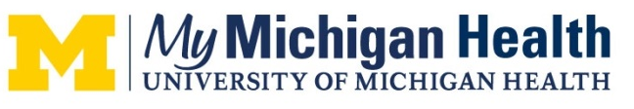
MyMichigan Health
4000 Wellness Drive
Midland, Michigan 48670
Phone (989) 839-3000
www.mymichigan.org

CME Activity Request Form
Please complete this form for activity review by our Continuing Medical Education department and/or the Continuing Medical Education & Life Long Learning Committee. You will be notified if more information is need and upon accreditation decision. Completing this form does not guarantee CME accreditation.

Event Title (what will be listed on flyer): Kratom 101

Date: 01/26/2024 Time: 12-1PM Location: Zoom

What is the educational need/practice gap (Please outline what is currently happening vs. what should be happening)?
Participants are not aware of the possible effects of Kratom and/or what Kratom is and why it is used.

Target Audience: medical professionals, social workers, addiction professionals, mental health professionals

Objectives (Please provide at least 3):
(1) Understand what kratom is and why people use it.
(2) Understand how to treat patients with kratom misuse and review patient cases.
(3) Understand the clinical effects of kratom intoxication and withdrawal.
Faculty & Planners
- Course Director: Sheba Sethi, MD

Faculty(Speakers):
- Sheba Sethi, MD
- Rob McMorrow, MD
Planners:
- Melissa DeMarse
- Emily McKanna
- Beth Seese

How will this activity be funded?

The training course is free for participants.

Would you like to do an outcome study to measure change in practice/performance?

YES NO

Will we be measuring change in performance with metrics?

YES NO

If you have any questions or need assistance completing this form please contact:

Teresa Oliver
Continuing Medical Education Specialist
MidMichigan Health
(989) 839-3330
Teresa.Oliver@midmichigan.org

